Roasted Salad🇬🇷

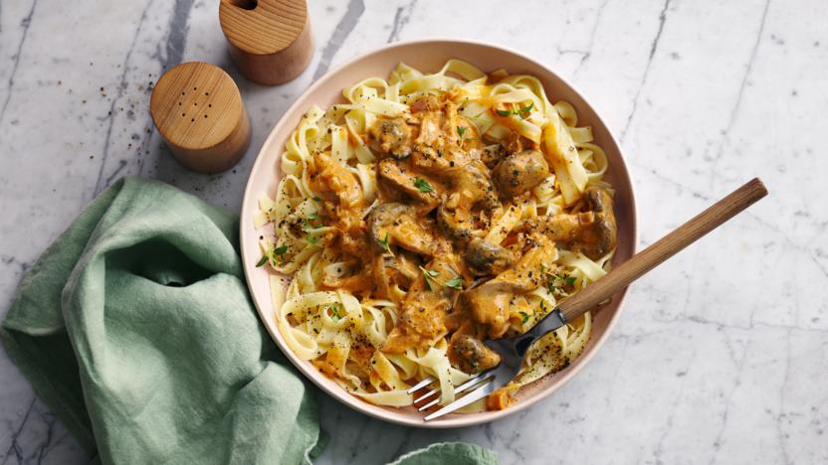
DID YOU KNOW?
“Who would have guessed that this purple oddball was actually a berry? Or that its unique flavor could turn any dish into a culinary masterpiece? Aubergines: the undercover fruit in your veggie drawer!”

Ingredients
1 aubergine
125g baby plum tomatoes
4 sundried tomatoes
3 garlic cloves
1 tin of green lentils
50g of feta
1 ciabatta roll
100g of baby leaf salad
2 tbsp of greek-style yoghurt
1 tbsp balsamic vinegar
10g of flaked almonds
1 tbsp olive oil

Nutrition – Total / Per Serving
Calories: 1044kcal / 522kcal
Carbohydrates: 128g / 64g
Protein: 38g / 18g
Fat: 38g / 19g
Fibre: 34g / 17g
Sugar: 34g / 17g

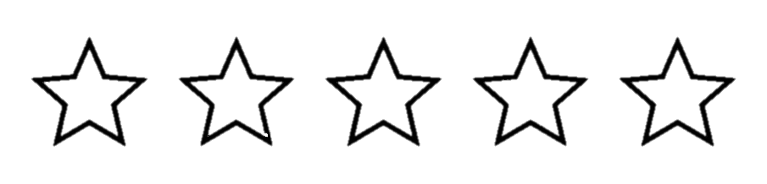




Good for:

Star Rating:

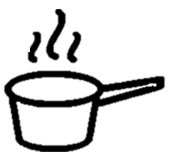

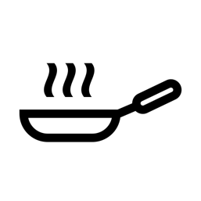

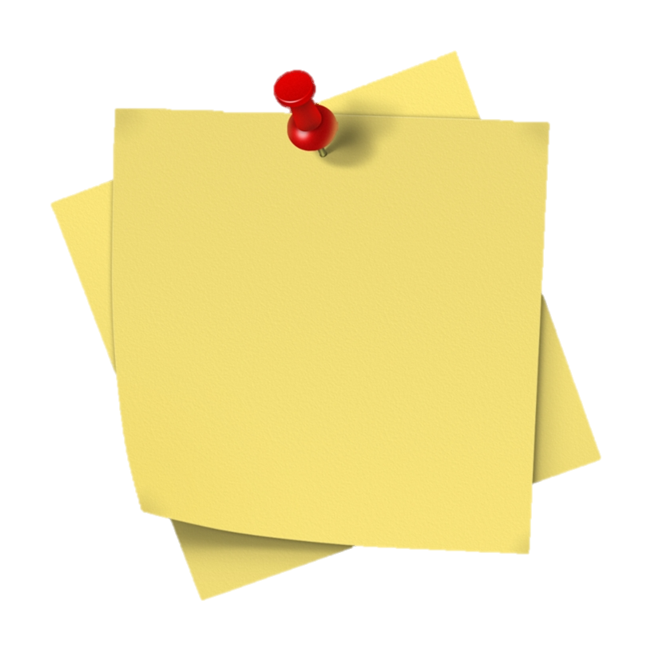
Method
Step 1 - Preparation
Preheat the oven to 220°C.
Chop the aubergine and tear the ciabatta into bite size chunks.
Halve the cherry tomatoes.
Drain the green lentils.
Chop and dice the garlic and sundried tomatoes.


Step 2 – Bake & Toast!
Spread out the aubergine and cherry tomatoes on a baking tray, leave some room to add the ciabatta chunks at a later stage.
Drizzle with oil and season with some salt and pepper to taste.
Place in the oven, it’ll be ~10 minutes before you add the ciabatta.

Heat the frying pan before adding the flaked almonds to toast them (keep stirring for ~3 minutes). Place in a bowl on the side for later.



Step 3 – Cook it & Make it Saucy
Add the ciabatta to the oven for the remaining 6 minutes.
Heat the now empty frying pan with some oil, once hot add the garlic.
Add the green lentils, mix well and allow to cook.
In a big bowl add the balsamic vinegar, sundried tomatoes, and 1 tbsp of olive oil.
Combine well before adding the lentils and garlic to the bowl.
Step 4 – Bring it Together
Remove the baking tray from the oven.
Add the aubergine and tomatoes to the big bowl.
Add the baby leaf salad and combine before dividing between the bowls.

Sprinkle with the baked ciabatta bites, toasted almond flakes, crumble on the feta and finally a dollop of the greek-style yoghurt. Enjoy!

